RadFXSat-2/Fox-1E CubeSat Description

Vanderbilt University / AMSAT – 1U

Version: December 20, 2017.

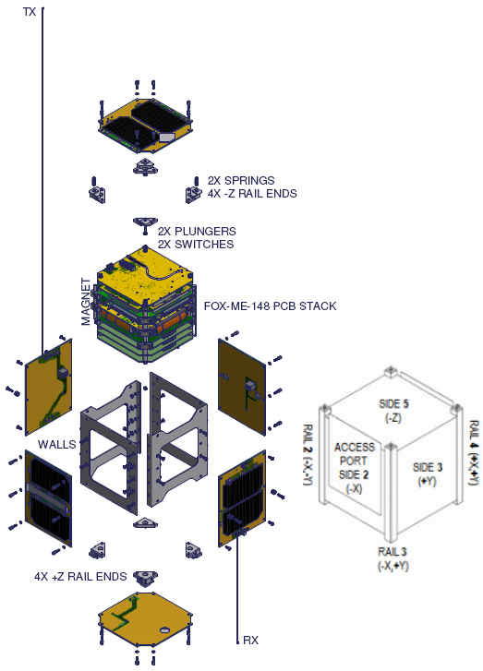

Figure RadFXSat-2 Expanded View

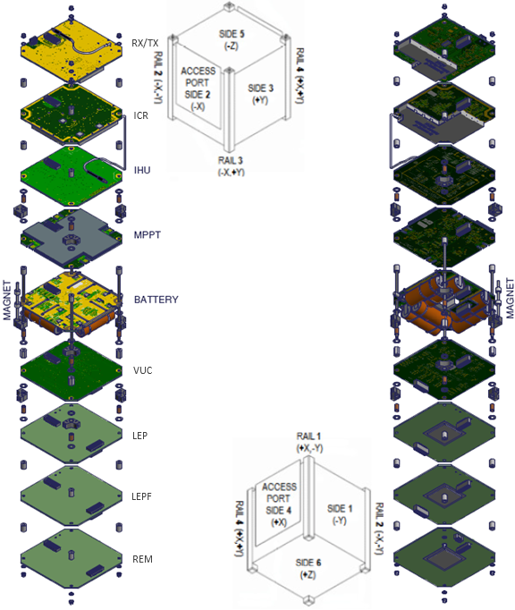

Figure RadFXSat-2 PCB Stack Expanded View

RadFxSat-2 is a 1U CubeSat designed by AMSAT and Vanderbilt University. It is controlled by AMSAT. Its mission has two objectives: two-way linear transponder communications in the amateur radio band, and to collect data on the effects of space radiation on SRAMs designed using FinFETs for the purpose of validating single-event error rate predictions. The amateur radio is a 30 kHz wide transponder with uplink in the two meter amateur satellite band and downlink in the 70cm amateur satellite band. The experiment consists of four boards: VUC, LEP, LEPF, and REM. The linear transponder (radio) consists of two boards: RX/TX and ICR.

CONOPS (abbreviated):

P-POD Ejection + 00:00 mm:ss - CubeSat deployed from the P-POD and CubeSat switches indicate successful deployment. IHU starts. Solar Panels may charge battery.

P-POD Ejection + 50:05 mm:ss - transmit antenna deployed (fishing line melt anticipated)

P-POD Ejection + 50:15 mm:ss - receive antenna deployed (fishing line melt anticipated)

P-POD Ejection + 50:21 mm:ss - transmission may begin

Design life is 5-15 years. Typical operations include V/u amateur radio communications and low duty-cycle telemetry. Operations are planned until re-entry.

*CubeSat material/construction description.* The primary CubeSat structure is made of Aluminum 5052-H32. Small machined parts are Aluminum 6061-T6, Copper 110, black Delrin, or G10 Fiberglass. The four long #4 threaded rods, and all #2 screws and jackposts are stainless steel. The PCB Stack includes experiments and avionics. Select ICs have small pieces of Tantalum as radiation shielding. The RF board(s) will have copper RF Shield(s). A large sheet of Lead is used as ballast on the bottomside of MPPT.

There is a Neodymium magnet approximately centered in Rail 2, and two Permalloy hysteresis rods bottomside of Battery.

There are no pressure vessels or hazardous materials.

The electrical power storage system consists of six commercial off the shelf (COTS) NiCad “A” size batteries (Sanyo KR1400AE; UL listing N/A; total capacity 11.5 Watt hours).